**Ec2 Instance**

An Amazon EC2 instance is **a virtual server in Amazon's Elastic Compute Cloud** (EC2) for running applications on the Amazon Web Services (AWS) infrastructure. AWS is a comprehensive, evolving cloud computing platform; EC2 is a service that enables business subscribers to run application programs in the computing environment. It can serve as a practically unlimited set of virtual machines (VMs).

Amazon provides various types of instances with different configurations of CPU, memory, storage and networking resources to suit user needs. Each type is available in various sizes to address specific workload requirements.

**Features of Amazon EC2**

* Virtual computing environments, known as *instances*
* Pay for what you use
* Amazon ec2 provides Scalable computing capacity in the aws cloud
* Various configurations of CPU, memory, storage, and networking capacity for your instances, known as *instance types*
* Secure login information for your instances using *key pairs* (AWS stores the public key, and you store the private key in a secure place)
* Storage volumes for temporary data that's deleted when you stop, hibernate, or terminate your instance, known as *instance store volumes*
* Multiple physical locations for your resources, such as instances and Amazon EBS volumes, known as *Regions* and *Availability Zones*
* A firewall that enables you to specify the protocols, ports, and source IP ranges that can reach your instances using *security groups*
* Static IPv4 addresses for dynamic cloud computing, known as *Elastic IP addresses*
* Amazon ec2 enables you to scale up or scale down the instances

**Types of ec2 instances:**

**1)General purpose:** It provide a balance of compute, memory and networking resources and can be used for a variety of workloads

**2)compute optimized:** compute optimized instances are ideal for compute bound application that benefit from high performance processors.

**3) Memory optimized:** they are designed to deliver fast performance for workloads that process large data sets in memory

**4) Accelerated computing:** it uses hardware accelerators or co-processors to perform functions such as floating point number calculations, graphic processing, or data pattern matching more efficiently than in possible in software running on CPU’s

**5) Storage optimized:** storage optimized instances are designed for workloads that require high , sequential read and write access to very large data sets on local storage.

**Why we use EC2:**

Because it provides scalable computing capacity in the amazon web services cloud using amazon ec2 eliminates your need to invest in hardware up front , so you can develop application faster

**Docker v/s Virtual Machine**

**DOCKER:** Docker is a software development tool and a virtualization technology that makes it easy to develop, deploy, and manage applications by using containers. A container refers to a lightweight, stand-alone, executable package of a piece of software that contains all the libraries, configuration files, dependencies, and other necessary parts to operate the application.

In other words, applications run the same irrespective of where they are and what machine they are running on because the container provides the environment throughout the software development life cycle of the application. Since containers are isolated, they provide security, thus allowing multiple containers to run simultaneously on the given host. Also, containers are lightweight because they do not require an extra load of a hypervisor. A hypervisor is a guest operating system like VMWare or VirtualBox, but instead, containers run directly within the host’s machine kernel.

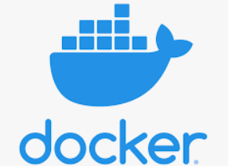

**VIRTUAL MACHINE:** A Virtual Machine (VM), on the other hand, is created to perform tasks that if otherwise performed directly on the host environment, may prove to be risky. VMs are isolated from the rest of the system; the software inside the virtual machine cannot tamper with the host computer. Therefore, implementing tasks such as accessing virus-infected data and testing of operating systems are done using virtual machines. We can define a virtual machine as:

A virtual machine is a computer file or software usually termed as a guest, or an image that is created within a computing environment called the host.

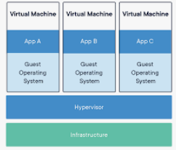

**Docker vs Virtual Machine: main differences**

The main difference between Docker and VMs lies in their architecture, demonstrated below.

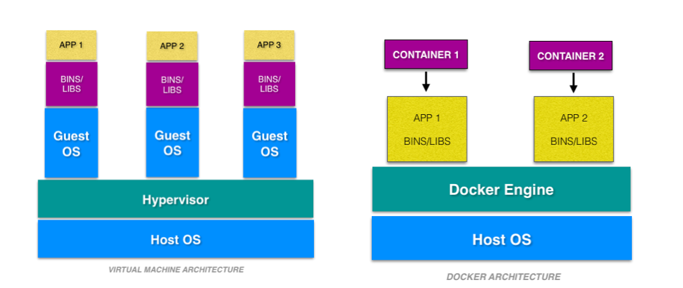

VMs have the host OS and guest OS inside each VM. A guest OS can be any OS, like Linux or Windows, irrespective of the host OS. In contrast, Docker containers host on a single physical server with a host OS, which shares among them. Sharing the host OS between containers makes them light and increases the boot time. Docker containers are considered suitable to run multiple applications over a single OS kernel; whereas virtual machines are needed if the applications or services required to run on different OS.

**Docker vs virtual machine**

|  |  |  |
| --- | --- | --- |
|  | **Docker** | **Virtual Machines (VMs)** |
| **Boot** | Boots in a few seconds. | It takes a few minutes for VMs to boot. |
| **Runs on** | Dockers make use of the execution engine. | VMs make use of the hypervisor. |
| **Memory Efficiency** | No space is needed to virtualize, hence less memory. | Requires entire OS to be loaded before  starting the surface, so less efficient. |
| **Portability** | Docker container are easily portable because they do not have seprate operating system | Virtual machine have Seprate OS , so porting virtual machine difficult as compared to containers and it also takes a lot of time to port a virtual machine because of its size |
| **Deployment** | Deploying is easy as only a single image, containerized can be used across all platforms. | Deployment is comparatively lengthy  as separate instances are responsible  for execution. |
| **Security** | Docker have a lot of security risks, and vulnerabilities as the container have shared host kernel | The virtual machine does not share operating system and there is strong isolation in the host kernel. Hence they are more secure as compared to containers |